roid

217, Sheikh Rashid Building

P.O Box 56272, Dubai

United Arab Emirates

Tel: +971 4 2973236 / 04 2974007

Email: uae@verbat.com

PROJECT   
PROPOSAL

**Hyper Local Search Engine**

|  |  |
| --- | --- |
| **Prepared for:**  **Mohammed Kassim** | **Submission Date:**  13 June 2017  **Proposal ID:** AD/BP/13062017/1343/1 |

___________________________________________________________________________________________________________________________________________  
Conﬁdentiality Notice: This Proposal is conﬁdential and contains proprietary information and intellectual property of Verbanet Technologies LLC. Neither this proposal nor any of the information contained herein may be reproduced or disclosed under any circumstances without the express written permission of Verbanet.

© 2017 by Verbanet Technologies LLC. All rights reserved. Confidential.

___________________________________________________________________________________________________________________________________________

Project Contacts

|  |  |
| --- | --- |
| Client Information | |
| Project Name | Hyper Local Search Engine |
| Client Name | Etisalat |
| Client Address | Etisalat Information Services, T&A Building,22nd Floor, Airport Road, PO BOX 3838,Abu dhabi, UAE |
| Contact Person |  |
| Contact Person Email |  |
| Contact Person Phone Number |  |
| Verbat Information | |
| Contact Person | Joyce Daniel |
| Contact Person Phone Number | +971 42973236 |
| Contact Person E-Mail | [joyce.daniel@verbat.com](mailto:joyce.daniel@verbat.com) |
| Address | PO Box 56272, Dubai, United Arab Emirates |
| Physical Address | 217, Sheikh Rasheed Building, Hor Al Anz East |
| Project Information | |
| Proposed Technology/Methodology | AngularJS, NodeJS, ExpressJS, MongoDB |
| Anticipate Start Date | NA |
| Proposal Valid For | 30 Calendar days from the submission of the proposal |

**Table of Content**

1 Scope of Work 7

1.1 Key Platform Stakeholders / “Actors” 7

1.2 Solution Objective 9

1.2.1 Redesign of home page 9

1.2.2 Search 10

1.2.3 Search Logic 10

1.2.4 Search Results 10

1.2.5 Business profile page 11

1.2.6 Integration Services 11

1.2.7 Map data 12

1.2.8 SEO 12

1.2.9 Languages 12

1.2.10 Site Catalyst & Ad Management server 12

1.3 Advantages of Proposed Solution 13

1.4 Why Verbat 14

1.5 Key Differentiators 15

1.6 Technology & Services 16

2 Functional Specification 17

2.1 Site Design & Development 17

2.2 Admin Features 20

2.3 System Features 21

2.4 Mobile features 23

3 Connect.ae UX Tear Down 26

3.1 Who are the key users? 27

3.2 What is the user’s number one critical goal in using the site? 27

3.3 What is likely to make the user’s experience particularly positive? 27

3.4 What is the approximate information architecture for the site? 28

3.5 What style(s) of navigation is/are used? Do they answer the key questions (Where am I and how did I get here? Where should I go next and how do I get there?)? 28

3.6 What key interactions does the user have? Are they clear and usable? 29

3.7 What did the site of well to allow the user to accomplish his goal effectively, efficiently, and with good satisfaction? 29

4 User Characteristics 30

4.1 Customers 30

4.2 Advertisers 32

4.3 Connect.ae 33

5 High Level Solution 34

5.1 High Level System Architecture 34

5.2 Keyword search 36

5.3 System Workflow (High Level) 37

5.4 Application Architecture 39

6 Nonfunctional Requirement (Others) 41

7 Assumptions 41

8 Out of Scope 42

9 Technology Solution 43

9.1 Proposed System Environment 43

9.2 Technical Configurations 44

9.2.1 Development Tools 44

9.2.2 Recommended Web Hosting Package 44

9.2.3 Browser Compatibility 44

9.2.4 Hardware Interface 44

10 Commercials 45

10.1 Web Application 45

10.2 Payment Terms 45

10.3 Mode of Payment 45

11 Delivery Management 46

11.1 Project Management 46

11.2 Roles and Responsibilities 46

11.3 Delivery Activity Summary 47

11.4 Project Implementation Plan 47

11.5 Deliverables 47

11.6 Estimated Delivery Time 48

11.7 Delivery Details 49

11.7.1 Phase 1 Web 49

11.7.2 Phase 1 & 2 Mobile (IOS & Android) 50

11.7.3 Phase 2 Web 50

11.8 Release Planning 51

11.9 Risk and Contingency Planning 51

12 Change Management 52

13 Miscellaneous 54

13.1 Acceptance Criteria 54

13.2 General Terms and Conditions 54

13.3 Assumptions and Dependencies 55

13.4 Source Code & Intellectual Property Rights 56

13.5 Maintenance & Support 56

13.6 Service Level Agreement 57

14 Our Clients 58

# Scope of Work

Etisalat Information Services (eIS) (Hereafter referred to as the “Client”) has tendered an RFP to aid in the design and development of a hyper local search engine (Web & Mobile apps) similar to connect.ae. The client wishes to develop a flexible and informative web site that is easy to maintain. The site shall be capable of delivering large amounts of constantly changing information to its primary users (the general public). The web site shall also be complimented by a companion application which could be deployed on mobile devices. The site shall have a CMS that can be integrated to the client’s CRM as well as the capability to publish static content. Publishing of editorials shall follow a standard approval workflow for publishing the said content.

The strategic objectives of this endeavor is to

1. Maximize the use of web-based technologies to provide an engaging user experience
2. Build a community and increase repeat visitors through innovative loyalty programs and improved customer service
3. Improve program delivery and service
4. Provide focused web-based solutions
5. Increase market share
6. Strengthen customer relationships and Retain current customers
7. Present comprehensive information and resources in an easy to use format

Verbat is pleased to submit the proposal and values it as a great opportunity to have a long term & mutually beneficial association with the client. Verbat has gone through the requirement and presents a proposal for the requested system.

## Key Platform Stakeholders / “Actors”

1. **The Public:** The single biggest user base of the purported application is the general public (hereafter referred to as the customer) who seeks directory services. Users of the general public use the services of the site to identify business, restaurants, theatres etc. It is critical to list business’ that are relevant and contextual to the search terms entered by the user
2. **Advertisers:** Advertisers (hereafter referred to as the advertiser) use the site to promote their business. Advertisers can choose from a variety of packages offered by the client depending on their needs. To mitigate and substantiate these expenses, eIS shall provide an assortment of tools that will justify the expenses. These tools will aid the advertiser in making better decisions on how to spent their advertisement funds as well as the tangible benefits earned through advertising
3. **Etisalat:**  eIS expects to make a profit in the process of providing valuable services to the community while stimulating the local economy through promotional advertisements. It is paramount for eIS to service both of these class of customers. In doing so, it needs to understand its customer base, be able to forecast their needs and make appropriate decisions. These decisions shall support strategic initiatives and shall be the primary driver towards technology adoption and overall program management.
4. **Editors / Publishers / Copywriters:** These are a class of users that are part of the eIS team who are responsible for managing and maintaining the static and editorial contents of the site. These users shall need approval / publishing workflows in order to stream line their tasks.
5. **System Admins:** System admins are responsible for managing and maintaining the application. Their primary responsibilities include directly interacting with the back office applications to provision new administrative or editorial users as well address client issues related to registration. Additionally they shall also be responsible for streamlining the application workflow. Examples include the management of backend jobs, schedulers, archives etc

**Stand-Alone Fixed Bid**

Verbat will be following a stand–alone fixed bid solution delivery model wherein the required solution would be devised and a suitable pricing would be offered.

## Solution Objective

Verbat intends to help the client build a world class hyper local search engine that is complimented by an extremely performant mobile application. The web portal being developed shall be visually pleasing and intuitive while not sacrificing on performance and security. It shall also be a responsive application.

With the above mentioned features being the overarching guiding principles, the following specific features will also be developed. The client’s RFP contains an explicit set of requirements, all of which will be adhered to by Verbat, unless called out separately as not being deliverable (in the “Out of Scope” section). Without having to repeat ad-nauseam sections of the RFP, Verbat would like to briefly touch upon the requirements that it will deliver. The “Functional Specification” section of this document will contain a detailed list of requirements that will be addressed in this solution proposal.

### Redesign of home page

#### CMS managed

* Header & Footer links
* Hamburger navigation links
* Home page background image
* Popular articles detail page.

#### Advertisements

* Promotions
* Time bound ads
* Featured deals and promotions prioritized by package selection
* SME Company profiles (similar to YP.com popular articles). Linked to static pages. (Refer to last point on CMS managed: section 1.2.1.1)

#### General

* Newsletter signup with database
* Advertise with us (similar to YellowPages- YP.com): Deals and package subscription services on separate page linked from home page
* Mobile app download section

### Search

#### Search UI & Suggestions

* Similar to google with location enable/disable buttons
* 5 dynamic suggestions, sensitive to every letter typed
* Suggestions based on relevance, geography and keyword prioritization based on packages
* Suggestion sources indicated by meaningful icons. Icons redirect users based on inbuilt logic

### Search Logic

* Access customer location (mobile and desktop), based on permissions granted
* GPS location (cell phones) and vicinity (desktop) send to Ad-network
* Create Geo fence based on map displayed (mobile-default & desktop)
* Determine context (fuzzy logic, normalization, synonym pairing, keyword stemming)
* Relevance logic based on name, address, phone, URL, Geography, free keywords & category
* Ranking based on advertisement package selected ( keywords, related categories and extra geographies purchased)
* Separate commercial packages for mobile and desktop

### Search Results

#### Generic page features

* Display similar to current connect.ae search result page, but shall be made more aesthetically pleasing
* Search result details for business will be based on the package selected.
* Users can post reviews.
* Review from connect.ae as well as other sites shall be aggregated
* Forward (share) company details via email and SMS
* Search result filtering based on review, distance, relevance
* Page headers to be fixed while scrolling
* Standard pagination with configurable listings per page (default 20)
* Listed properties should be numbered and visibly located on the map

#### New features

* Map functionality to be explored for displaying business listed on the page
* Real time in page (in app) navigation
* Real time in page (in App) communication interfaces (click to call services). Customer sees green phone button, if the advertiser is available to answer a call via app.
* Sponsored text based ad’s
* Smart suggestions for keywords and categories
* Place holders for display ads managed by Ad-Management server

### Business profile page

#### General features

* Profile page listing based on the Ad package selected. Additional information for the profile will be collected from the back end.
* Profile page to be identical to the existing connect.ae page
* Profile page information shall be sharable via email, SMS, V-Card & social media
* Click to call services for in place communication
* Map–to–location in page driving directions

#### Micro-services to retrieve profile information

* Application shall use micro services based architecture to retrieve various components of the profile. Namely
  + Product logo with link to company
  + Product home page link to company
  + Product email
  + Product click to call
  + Product company description
  + Permission product ranked word search limit
  + Permission product deep links
  + Permission products pdf
  + Permission product search word ad limit

### Integration Services

Platform aggregation through Integration with potential service providers like

* Booking.com
* Zomato.com
* Roundmenu.com

By integrating services from other platforms, the application shall be able to provide better user experience. Integration and aggregation services shall be done in phase 2. Verbat has experience integrating third party services and products.

### Map data

Integration of map data based services, provided by a third party is subject to how well the service has been documented. Clear definition of API’s and data contracts would make it easy to implement. Verbat is conversant with mapping API’s provided by google in all platforms.

### SEO

Primary requirements for Search Engine Optimization are

* Configurable hamburger navigation
* Bread crumb trails
* No follow tags & Schema tags
* Human friendly urls
* Static content for categories. Category pages must be editable via CMS ( similar to souqalmal.com)
* Metadata for category pages via configurable rules. Assign metadata programmatically

### Languages

* English & Arabic

Detailed requirements will be covered in the section titled “Functional Specifications”

### Site Catalyst & Ad Management server

Verbat can provide services to configure site catalyst as well as Client procured Ad-management server

Verbat’s Solution architects have conducted a thorough research on the requirements and have come to the conclusion that our proposed solution, which is detailed further in this document, will meet the requirements put forth by the client. And the proposed solution will be delivered in a phased approach as per Verbat’s stand-alone fixed bid solution model.

**Strong and Scalable platform:** The platform proposed will be strong and scalable enough to accommodate future enhancements.

**Accelerated solution:** The framework would act as a solution accelerator. It would provide the basic building blocks which could be reused in future for building new components and features.

**High performance:** The light weight framework used consumes fewer system resources thereby making the application perform faster.

**Security:** The application will be developed considering various aspects of security.

## Advantages of Proposed Solution

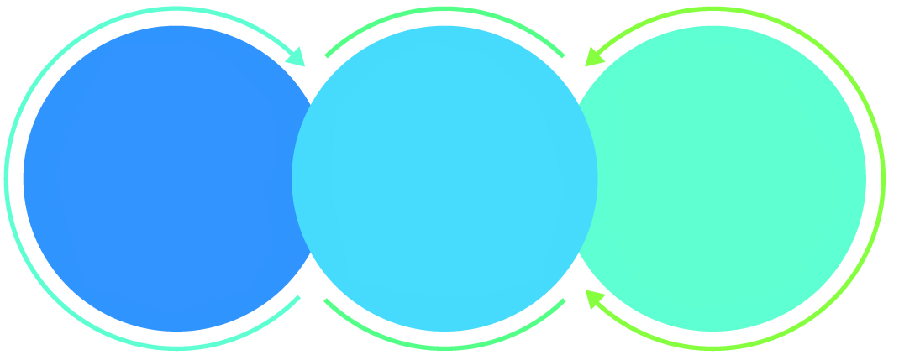

01

Agile development offering reliable, secure solution

02

Smooth transition and quicker completion of processes

03

User friendly interfaces enabling easy navigation between screens

## Why Verbat

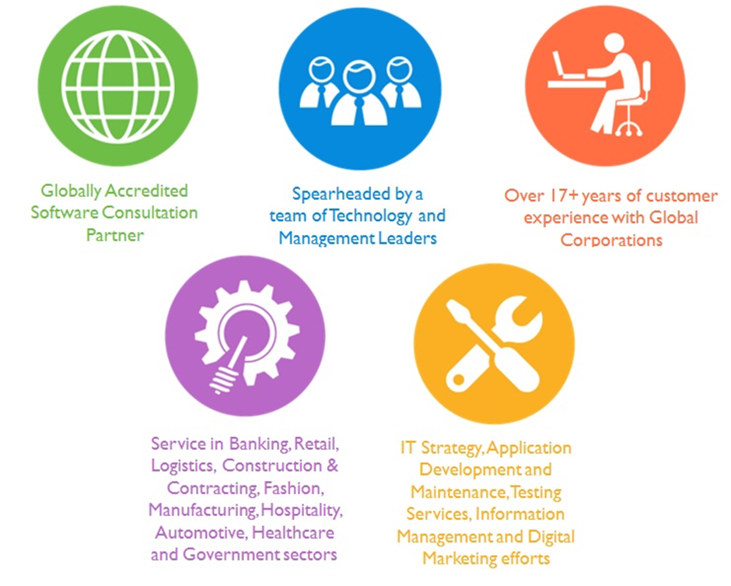

## Key Differentiators

Delivered digital transformation expertise to global customers for over a decade by following industry best practices to maximize ROI for client

Keen technology intelligence combined with aggressive market research to deliver solutions that achieve results with measurable value

Enable access to global consulting expertise with strong local market and business knowledge

Commercial Model that is customizable for your business needs

Services that are designed to optimize applications for improved performance and overall efficiency

1,000,000 plus man-hours of expertise in technology frameworks spanning Microsoft, Open Source, mobility platforms and other proprietary IT technology

Partners top technology vendors to bring in the latest and best services in integration, collaboration, and development

Commercial Model that is customizable for your business needs

Proven Methodologies & Processes

Investment in R & D

Strong Local Presence

Flexible commercial Models

Technology Associations

Software Development Experience

Offshore Development Centre

Quality Assurance & Testing

## Technology & Services

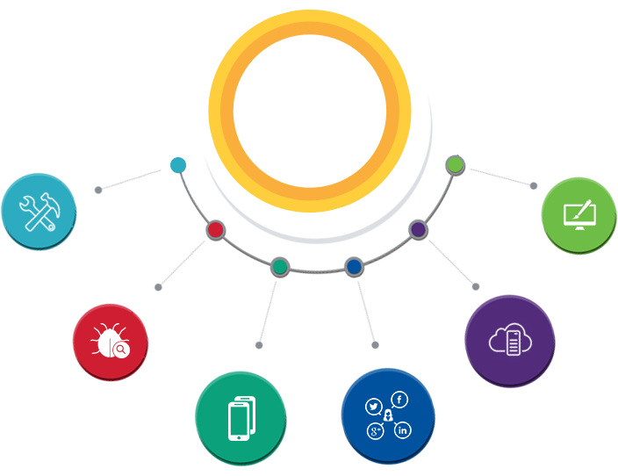

Technology  
&  
Services

Cloud/Traditional Hosting

User Interface & Design

Digital Marketing

Mobility Solutions

Testing Services

Application  
Development

# Functional Specification

## Site Design & Development

|  |
| --- |
| **Site Design & Development** |
| Home page (Inspiration yellowpages.com, connect.ae) |
| **Home Page Sections** |
| Time sensitive adverts & promotions |
| Featured company section |
| Mobile app Download section |
| Header |
| Logo, language Selection, login, Signup |
| Footer (links managed by admin) |
| About Us |
| Contact |
| Advertise |
| Help |
| Privacy |
| Terms of use |
| Frequent Searches |
| Feedback |
| Site Map |
| Hamburger Menu |
| Newsletter signup |
| Dynamic image behind search bar |
| Social media links |
| Search Bar (location enable option + Map view results option) |
| **Company Profile page (Refer YP.com detailed pages)** |
| Dynamic sections based of membership type. Sections suppressed for non-privileged users |
| Detailed profile pages similar to Yellow Pages company directory |
| **Page Details** |
| Tabbed (Business details, Coupons, Gallery, Reviews) |
| Business Details |
| Description, logo, opening hours, deep links, video, social media links |
| Send email to company (mobile and web) |
| Forward company details via **SMS (mobile)** |
| Save company details as vCard (mobile) |
| Click to call (mobile) |
| Post in social media |
| Web Address, Price range, neighborhoods, categories |
| List of features (Child safe, cuisine, attire etc.) |
| Order online (link) |
| View Menu (link or image) |
| Suggest an edit |
| Years in business |
| Reviews count on top connect.ae & aggregators count |
| Overall Rating |
| Reviews (tabbed) |
| Reviews from connect.ae |
| Reviews from aggregators |
| Image gallery, |
| List Reviews |
| Post Reviews |
| Related searches |
| Advertisement section |
| **Generic page design (content managed by client)** |
| **Search bar features** |
| 5 dynamic search results (refer connect.ae) |
| Each result prepended with icons (one of briefcase, magnifying class, clock, POI) |
| Magnifying Glass: Directs to the search results page (results from internal source) |
| Briefcase: Directs to the company profile |
| Clock: use previous search result for the keyword in use |
| POI: Directs to map |
| *For tablets and mobiles, results based on location* |
| **Search Results page (Combination of Connect.ae & YP.com)** |
| Total results returned |
| List of 20 results page |
| map with number tags (resizable) |
| Sort by relevance, distance popularity ( like connect.ae) |
| filter by order online, kid friendly etc. (similar to YP.com) |
| About Search results |
| Sponsored results |
| Map fixed while scrolling |
| Sponsored advertisements on right panel |
| Homepage header fixed while scrolling |
| Suggested keywords |
| Reset search filters and sorting to defaults |
| **Search results details (individual listing)** |
| Thumbnail image, Social media links |
| Phone, fax & address, Number on map |
| Hours of operation |
| Description |
| Rating (connect.ae & aggregator) |
| Website address and Menu, Order online (link), Order online (link) |
| Categories (list) |
| Clicking on map number resizes and zooms the map with selected number and surrounding listings |
| **Registrations** |
| User registration |
| Advertisement registration |
| Register via social media |
| **Directions to location (Map Details page)** |
| Print Directions |
| Route on map |
| Directions list |
| Map Coordinates |
| **SEO** |
| Breadcrumb trails |
| No follow tags for hyper links |
| Schema tags for internal search engine (like u tube) |
| Human readable URLs |
| static content for category pages |
| update met tags dynamically (using varnish) esp. for category pages |
| Responsive design |
| **Admin Dashboard** |
| Screens for master data |
| Screen for Users, categories, adverts etc. |
| Advertisement Revenue management |
| API management |

## Admin Features

|  |
| --- |
| **Site Management (Admin & Advertisers)** |
| **Category management (metadata)** |
| Time bound categories |
| Categories by package (Free, Visible & Ranked, The Look) |
| Free : Registration includes address and free categories |
| V&R: Free + Ranked Keywords + Keywords connected to categories |
| The Look: V&R + Logo, Gallery, Deep links, Text etc. |
| Manage Hamburger links |
| **Advertisement management** |
| Image, description, icon, gallery, Map coordinates, Address, Phone, Fax, Name |
| Category, Ranked keywords, Deep links, keywords related to categories, Email |
| Social media links, open hours, holidays, payment methods, accreditation, coupons |
| **Coupon management** |
| Coupon images, Description, Discount price, discount %, Referral ID, Coupon code |
| coupon URL, Coupon name, Category, Company name (implied) |
| **Newsletter** |
| Create news letter |
| Manage content |
| Associate distribution list |
| **Member registrations (Company profile)** |
| name , email, phone, address, phone, fax |
| Social media links, open hours, holidays, payment methods, accreditation, coupons |
| Image, description, icon, gallery, Map coordinates, deep links, linked advertisements |
| Linked coupons, Linked categories (ranked key words, related categories etc.), category type |
| **Template for Static Pages (managed Content)** |
| About, Contact, Advertise, Help , Privacy, Terms of use, feedback, |
| **Manage Time bound adverts** |
| tag line, image, URL etc. |
| Manage Packages (categories) |
| Manage Search bar background image |
| place holder for paid advertisement side bar |
| Manage footer links |
| Manage Web site users |
| Reporting with filters for date, location & segments |
| Company search keyword – all & specific keywords |
| Customer ID – company wise |
| Link click report |
| Map interaction report |
| Site Unique visitors/visits, page views, sections etc. |
| Most/Least viewed listings |
| Most/Least leads generating listings |
| Most/Least viewed multimedia (Videos/Pictures/Sound Clips) |
| Manage memcached or similar |
| Smart Metrics UI from Varnish |
| Ranked Search word limit |
| Deep link list limit |
| Manage access to API |
| Admin dashboard |
| **Content manager roles** |
| Manage roles (author, reviewer, publisher, editor) |
| Add users to roles |
| **Adv. management** |
| Adv. trafficking and delivery (behavioral and contextual targets) |
| Audience categorization: Target audience age, marital status, financial outlook, time of day |
| Product categories, season, time of year |
| Advertiser preferences |
| Frequency capping for adverts |
| Pricing models (create and manage) : CPM, CPC & CPD |
| Customizable targeting criteria |
| **Advertisement Revenue Reports for connect.ae & expenses for advertisers** |
| sponsorship, rich media, leads, classifieds, digital video, etc. |
| Mobile, desktop, banners, search |

## System Features

|  |
| --- |
| **System Features** |
| Authentication and Authorization |
| Permission based access levels |
| Bilingual website |
| Advanced workflow and approval process for content management |
| Content management framework |
| Auditing and logging |
| **Semantic analysis of keywords** |
| Word recognition using fuzzy logic |
| word stemming |
| synonym recognition |
| Geographic context analysis (to enable hyper local search) |
| Rule based search results |
| parameterized search result limit |
| search dropdown categorization |
| Web Based search results |
| Mobile based search results |
| Search results based on geo fencing |
| Randomization of search results for results with identical priorities |
| **Advertisements** |
| Time bound advertisements |
| Context sensitive advertisements based on key words |
| integration with advertisements networks |
| Detailed company page based on package |
| **API calls** |
| company |
| product: logo |
| product: homepage |
| product email |
| Product: click to call |
| Product: company description |
| permission product: Ranked search word limit |
| permission product: deep link |
| Permission product: PDF |
| Mobile search logic order: local, comprehensive, paid adverts first, |
| payment processing |
| **CRM data flow** |
| add customer from web to CRM |
| Scheduled job generates Excel sheet |
| move the spreadsheets to landing pad via SFTP |
| Advert XML generated from the spread sheet and pumped to ActiveMQ |
| **Search Integration with 3rd party** |
| Zomato |
| booking |
| RoundMenu |
| **Reviews integration** |
| Zomato |
| Tripadvissor |
| Roundmenu |
| Connect.ae |
| **Map Integration** |
| Zoom in and zoom out |
| driving directions |
| Search result page |
| API for mobile devices |
| Scheduler related |
| Sort and filter for search page |

## Mobile features

|  |
| --- |
| **Login page** |
| Design and development |
| **Signup** |
| Design and development(API integration, Validation) |
| Register with social media(Face book and Gmail) |
| **Home page** |
| Page design |
| **Sliding menu(Hamburger Menu)** |
| Frequent Searches |
| Feedback |
| Newsletter signup |
| language Selection |
| **Search Bar (location enable option + Map view results option)** |
| location enable option |
| Categories (list) |
| **Search Result** |
| List view |
| **Frequent Searches** |
| List view |
| **Feedback** |
| Feed back page design ,API integration |
| **Newsletter signup** |
| Page design and API integration |
| **language Selection** |
| Popup design , API integration, Development and language integration |
| **Detail Page** |
| **Tabbed (Business details, Coupons, Gallery, Reviews)** |
| Business details |
| Coupons |
| Gallery |
| Reviews |
| Advertisement section |
| **Business details Design and API integration** |
| Description |
| opening hours |
| deep links |
| Video |
| social media links |
| Send email to company |
| Forward company details via **SMS** |
| Save company details as vCard |
| Click to call |
| Post in social media |
| Web Address, Price range, neighborhoods, categories |
| List of features (Child safe , cuisine, attire etc.) |
| Order online (link) |
| View Menu (link or image) |
| Years in business |
| Reviews count on top & aggregators count |
| Overall Rating |
| Map view results |
| **Coupons** |
| Page design and API integration |
| **Gallery** |
| Page design and API integration |
| **Reviews** |
| Reviews from Admin |
| Reviews from aggregators |
| Post Reviews |
| **Advertisement section** |
| Page design and API integration |
| **deep links** |
| web view and API |
| **Video** |
| Page design, API integration and video player integration |
| **Send email to company** |
| Page design , API integration and email integration |
| **Forward company details via SMS** |
| Page design , API integration and SMS gate way integration |
| **Save company details as vCard** |
| Page design and Development |
| **Click to call** |
| API integration, Click to Call integration |
| **Post in social media(Face book)** |
| Development |
| **List of features (Child safe, cuisine, attire etc.)** |
| Page design and API integration |
| **Reviews count on top & aggregators count** |
| API integration |
| **Map view results** |
| Show Directions |
| Route on map |
| **Reviews from aggregators** |
| Page design and API integration |
| **Post Reviews** |
| Page design and API integration |
| **Show Directions** |
| Create map view and draw the direction |
| **Route on map** |
| Create map view and draw the direction |
| **Developer side testing and bug fixing** |
| **Page design , icon design in Photoshop** |

# Connect.ae UX Tear Down

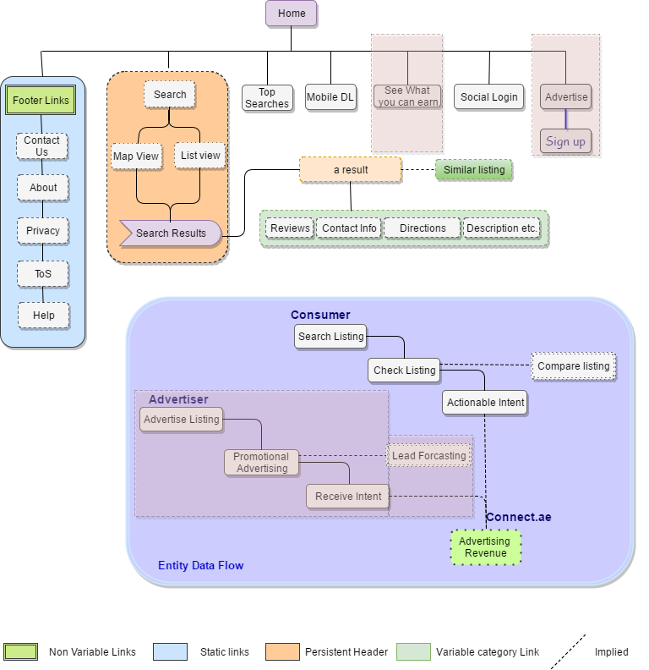

Figure 1 Approximate Information Architecture

Verbat has thought at length the various possibilities for enhancing the site. Some questions that came to the forefront were worth looking into. The user design tear down depicted above helps to answer few important questions like

## Who are the key users?

From the image above it can be evidenced that there are 3 key users of the portal, but the chief among them being the customer or the casual browser. Behind the scenes the site is also used by advertisers

## What is the user’s number one critical goal in using the site?

* Customers visit the site primarily to obtain information regarding products or services on the go. Thus they are very much influenced by convenience and the speed at which they can obtain this information.
* Advertisers will use the site because it is an excellent platform for them to parlay their products and services to a wider audience without having to incur costs associated with traditional sales and marketing services.
* The ultimate goal of the clients is to make a profit out of revenues earned from advertisers. To achieve this goal they have to whet the appetite of the aforementioned demographics. As a result they have to device innovative and disruptive service models.

## What is likely to make the user’s experience particularly positive?

As mentioned above convenience and speed of receiving services or products is the epitome of a positive customer experience. To fulfill this, innovative services such as click to call, map to location, instant reservations & appointments (like booking.com) and a variety of other services can be implemented to transform connect.ae as the go-to destination for users.

Beyond this, the site has to cater to the basic requirements of a search query, which is relevance and location centric results.

## What is the approximate information architecture for the site?

The image depicted above is an approximate information architecture for the site. It identifies the main actors and their data needs.

Advertisers are invited to participate on the site with a link that describes the tangible benefits from joining the site. This includes a projection on potential revenue as well as the tools that they are able to afford to measure the realization of their marketing efforts.

Consumers have a variety of flows that they can choose. Depending on whether the result returns a hotel, restaurant, shop or a convenience store; consumers may choose to drive, chat, talk or book a reservation. (Among others)

## What style(s) of navigation is/are used? Do they answer the key questions (Where am I and how did I get here? Where should I go next and how do I get there?)?

The current web site addresses this questions inadequately. However the proposed site takes into consideration the SEO elements of the site. This has been covered in an earlier section.

In general most of the navigation is located within the main page of the site. There are header and footers but they can largely be ignored, as the most commonly used header buttons are the home button, which is large and easily visible, and the new search bar, which is equally identifiable. Once the user has performed a search, the main window is broken up into 3 sections: filters, results, and a map of the area showing a quick overview of numbered locations. This page has a persistent header (not sticky header) that lets the user know what area they had originally searched for and makes it obvious where they came from. After selecting to view a result, the browser opens a new page with more information laid out for the user. The new page allows for the user to easily know what the original search query was and the category. The company profile page has a persistent column on the right-hand side that sows the map location along with an option to get directions to the location.

## What key interactions does the user have? Are they clear and usable?

The key interactions available to the user are searching for products or services. They are clearly geared towards a singular goal, uncomplicated, and straightforward. This simplicity of design is definitely a strength in some areas, but can also be a little frustrating for users. The interactions keep it uncomplicated but sometimes that simplicity doesn’t allow for a depth of usability that some may want, at least not clearly stated.

## What did the site of well to allow the user to accomplish his goal effectively, efficiently, and with good satisfaction?

The site allows for an easy flow from start to finish and it is clear what their objective is for the user. The information is displayed so it is easy to find and read and is consistent from page to page. There are options to search for hotels, restaurants, businesses, etc. along with directions for the same. Businesses that were similar nature were also displayed. With a shallow navigation and calls to action that stick out a user would be hard pressed to get lost while using the site.

# User Characteristics

## Customers

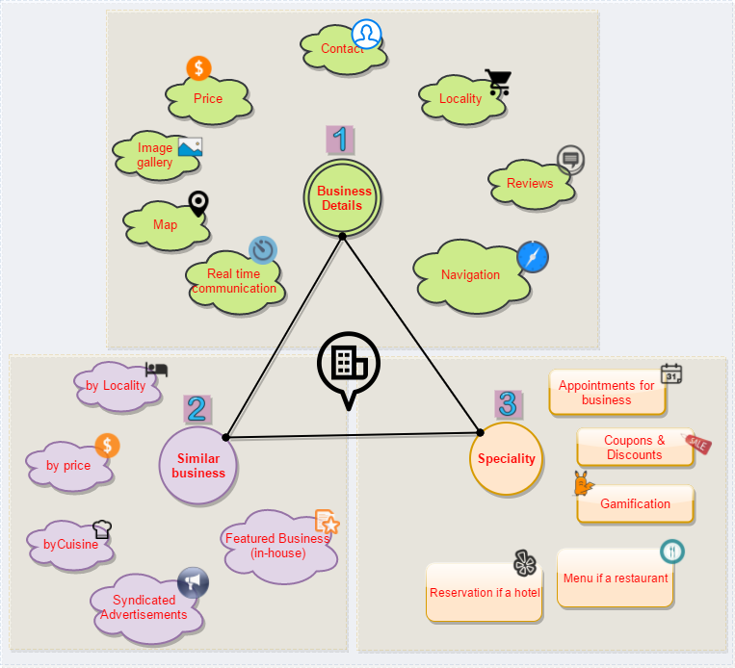

The image above is self-explanatory. It describes the three main interactions a user may have with a hyper local directory service site. These interactions are numbered 1-3, the order by which the engagement transitions from casual to personal.

The user visits the site to casually browse for something of personal interest. The site delivers relevant results based on the search criteria. This search result details are augmented by next generation communication and collaboration tools that hastens the decision making process. In-App (web or mobile) navigation presents itself as a prodigious opportunity to sway customers and turn them into followers. Convenience being the key guiding principal.

Often times, customers are not sure what they are searching for, simply because they are not able to express themselves, at other times because they lack knowledge. Related searches, help the customer to discover new categories, at other times, it helps them to describe what they are really looking for. If related information is presented properly based on relevance, location etc. it helps them to make wiser decisions. These type of interactions create lasting impressions and enhance the brand value of the portal.

The culmination of a successful interaction is an actionable event with intend. This can vary from

* A phone call to the establishment
* Directions to the location of the establishment
* Appointment with the establishment (ex. Appointment with a hairdresser or reservation at a restaurant)
* Booking ticket for a movie
* Reserve room at a hotel
* Gamification through reward points or similar

These are interactions that are more personal in nature and require specialization i.e. native integration with other third party service providers.

## Advertisers

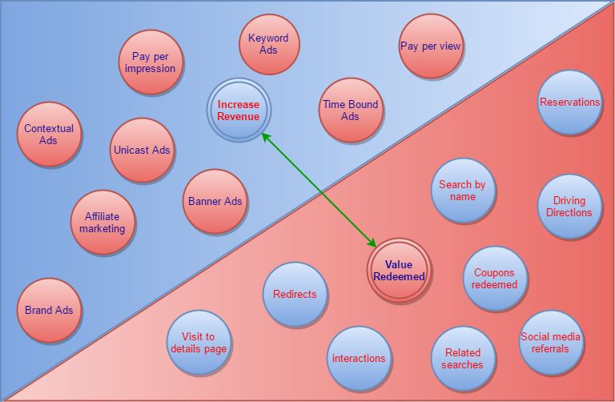The image below depicts the different options the advertiser has to display advertisements on the portal. This is juxtaposed to measures that ca be used to determine the tangible benefits realized through advertisements.

Advertisers can subscribe to any one of the advertising options listed below or they may subscribe to a package which is a combination of the different options

* Brand Ads: A form of advertisement where a brand (not necessarily a product) is promoted. Money may be pooled by several advertisers to promote the brand that is featured prominently in their establishment.
* Affiliate marketing: A third party agency manages the advertisements. Ad-placements are based on their programming
* Banner Ads: self-explanatory
* Unicast Ads: Similar to banner ads, but instead of images, videos are displayed
* Contextual Ads: Self explanatory
* Pay per click, pay per view: Industry standard advertisement options
* Time bound Ads: Advertisements placed based on the time f day
* Keyword Ads: Self explanatory

Advertisers can measure the effectiveness of their campaigns by analyzing the user interactions. These interactions can be quantified and tracked. Some of these business metrics are listed below

* No of visits to the profile page
* Redirects to the company site
* Interactions with the business. Interactions can be click to call, chat, message etc.
* How often the business was listed in related search
* Social media referrals
* How often and how many times were coupons redeemed
* How often were they searched by name
* How often was driving directions listed for the business

These are some sample metrics that could be used by the advertiser to fine tune their campaigns. It is also a testament to the increase in revenue earned from advertising on the platform

## Connect.ae

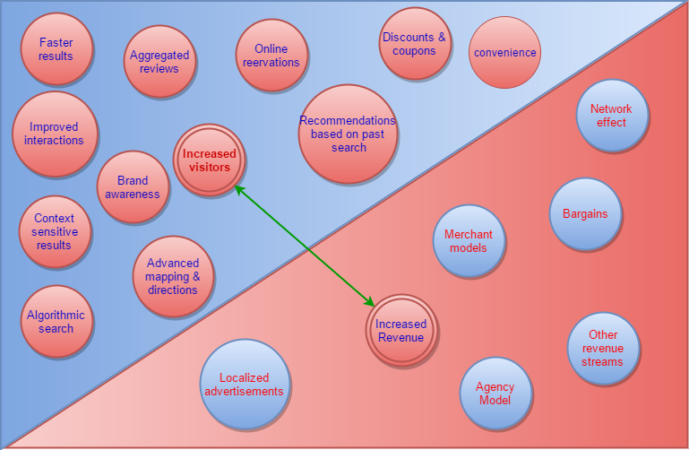

The primary purpose of this web portal for Etisalat is to increase revenue. To advance this agenda, the portal shall provide the following services. Most of these concepts have already been discussed.

* .Algorithmic search results
* Advanced mapping and directions
* Context sensitive results
* Increased brand awareness
* Enhanced interactions
* Aggregated product and service reviews
* Specialization in products and services through native integration
* Discounts and coupons

While the above services attract customers, the platform will provide the following services to maximize revenue. Some of these are standard industry models, while others are specific to the platform

* Localized advertisements
* Agency model
* Merchant model
* Bargains and package sale
* Network effect through brand awareness
* Other revenue streams that are outside the scope of this document.

# High Level Solution

## High Level System Architecture

The short version of the architecture described are

* Static and dynamic data cached up front on varnish
* Even though Nginx can handle L7 load balancing, Perlbal offers better flexibility with its plugin system
* Jetty application servers easily scale out by using memcached as the session store
* Write intensive operations are done asynchronously via the ActiveMQ message store system
* One SQL database on RAID1 with a hot standby database on a third disk.

The architecture above can handle 6000+ request per second, however it can be scaled out to accommodate higher orders of traffic

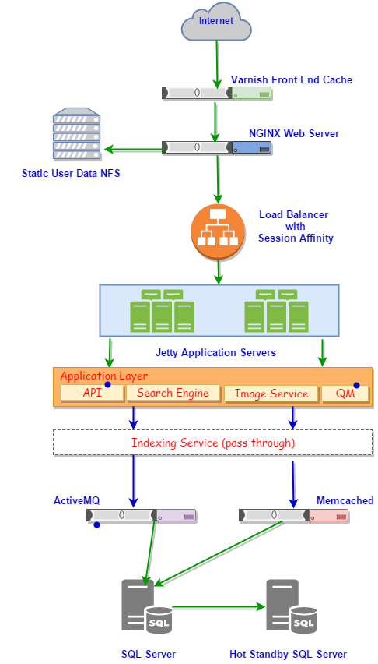

Figure 2 High Level Technical Architecture

## Keyword search

Figure 3 Overall Workflow

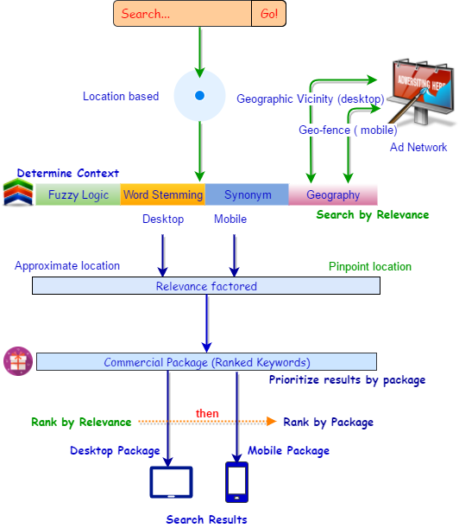

The image above is a conceptualization of the search algorithm described by the client. Keywords are analyzed for etymology, context, geographic information and relevance. The package definitions are applied over the results to derive the final result. Search keyword results are attributed with additional information such as business, map, and context etc. using stylized icons. Search results are interpreted differently for desktop and mobile devices.

## System Workflow (High Level)

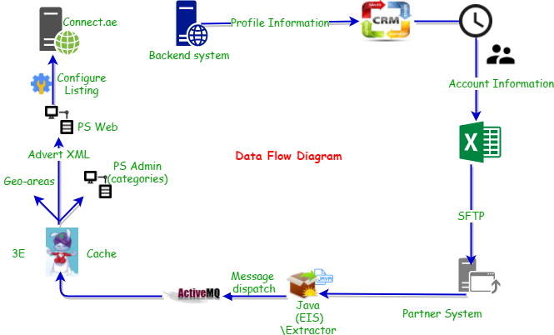

The

Approximate dataflow as described by the client is depicted the image above.

* Details about an account in updated in CRM. Free listings are updated with address, phone, and email details and for paid customers product details are added.
* Every day evening we have scheduled job which generates excel files of all the accounts, it has previous accounts also and the changes which was done over the day.
* Once excel file is generated its copied to the Partner System using SFTP
* The files copied to Partner System is used to generate Advert XML, these XML is the input for the production site
* The xml file is generated using Java package EIS-Extractor and the extractor will send Active-MQ message about the XML generated to 3E systems. The 3E system in turn picks this XML for further processing.
* 3E stands for Partner Extract Engine and is a high-performance cache for data deliveries to various systems
* Data delivers from backend systems(in our case advert XML) to Index
* Technologies used are Uses JAVA, Active-MQ, and Mongo-DB. This is handled by Partner Team and we don’t have any control on 3E system.
* 3E Intended as a tool where
  + data is transformed (for example from XML to Advert XML),
  + added together (for example Advert XML added with PSM data)
  + cached for fast full file deliveries (for example to Index, which requires a new full each day, and where source systems like ECO do not provide any full files)
* Once 3E processing done information about a customer listing is present in PS-WEB. For paid clients the product details (keywords, category/profile ad, deep links, offer ad, pdf, cover photo, openings hours) are added in PS WEB. Once added in PS-WEB info will be updated in advert XML file.
* Products like logo, web address, social media links, and images are taken directly from Advert XML data. Images are copied to predefined path in Partner system.
* Categories are stored in PS-ADMIN which is updated through a scheduled job.
* Geo-areas are stored in Partner Database and is used while Advert XML are generated

## Application Architecture

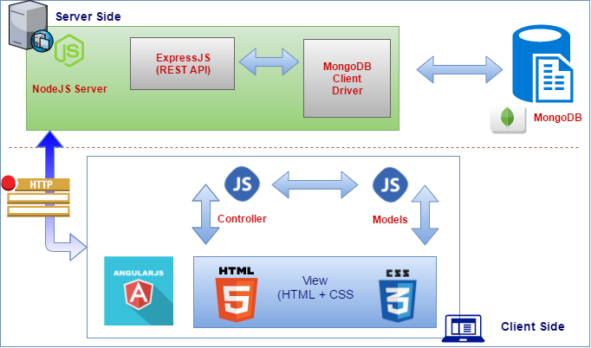

The proposed architecture uses a JavaScript based web application stack popularly known as the MEAN (Mongo DB, Express, Angular & NodeJS) stack.

Angular is a Single-Page Application (SPA), a Web app that loads a single HTML page and dynamically update that page as the user interacts with the app. SPAs use AJAX and HTML5 to create fluid and responsive Web apps, without constant page reloads.

In the MEAN stack NodeJS is JavaScript based server. Node.js is a fast and scalable network application. Node.js uses an event-driven, non-blocking I/O model that makes it lightweight and efficient, perfect for data-intensive real-time applications that run across distributed devices.

Express.js is a Node.js web application server framework, designed for building single-page, multi-page, and hybrid web applications. It is the de facto standard server framework for node.js. Express enables you to easily create web applications by providing a slightly simpler interface for creating your request endpoints.

MongoDB stores data in JSON-like documents that can vary in structure. Related information is stored together for fast query access through the MongoDB query language. MongoDB uses dynamic schemas, meaning that you can create records without first defining the structure, such as the fields or the types of their values.

The technology stack proposed above uniquely qualifies for the stated requirements of speed and versatility. The dynamic nature of MongoDB schemas lends itself to the requirement as each business can have its own unique business constraints.

# Nonfunctional Requirement (Others)

|  |  |
| --- | --- |
| **Requirement** | **Details** |
| User Experience and  UI Design | * The application will be developed only in English and Arabic * The layout and graphical components will be created considering the usability factors |
| Performance | * Application will allow users to have smooth and quick access to the information or services they require. |
| Security | * The system will be protected against attempts of security breaching that may arise. * Web security standards will be followed. |

# Assumptions

The project solution and technology is created from the initial understanding of the requirement shared with Verbat through mails and meetings. The proposed solution is based on the following assumptions:

* Client to provide Verbat with the branding guidelines.
* The proposed application will be bilingual (English & Arabic)
* Client will purchase the necessary templates needed for development
* Client shall provide licensed images and logos in specified size & format
* Requirements should be well defined, agreed and signed-off by the client
* Internet connectivity is required for the functioning of the web application.
* Customer will procure templates, SSL certificates & Payment processor
* Client will procure Site catalyst
* Client will procure Ad-Management server
* Client will provide access (API) to aggregation sites
* Client will provide access to third party integration services
* Client will provide API access and API’s for map integration
* Client will procure SMS gateways
* Testing will be done in latest versions of Google Chrome, Mozilla, Safari, & Edge web browsers only
* Development Contingent upon timely feedback from client
* UI effort is based on the impression that client will need a custom designed pages for unique content (as opposed to development based on procured templates). Design effort may be reduced by half if the design is based on templates

# Out of Scope

Following are considered to be out of scope while creating this proposal.

* Purchase of images, fonts
* Adding new features to the application other than mentioned in the functional specification.
* Any language other than English & Arabic
* Manual data entry
* Hardware Integrations / procurement and purchase
* Database migration
* Content writing
* Content or image procurement or uploading or editing.
* Hosting Infrastructure and Maintenance
* Annual Maintenance of the application (Bug fixing, debugging) - For AMC details, please refer section titled “Maintenance and Support”
* Physical deployment at client’s site
* Backup solution and Disaster recovery

# Technology Solution

## Proposed System Environment



NodeJS, Express, MongoDB

Angular

HTML / CSS3/ Jquery

**MS SQL2012  
Windows 8/10  
Web Services**

## Technical Configurations

### Development Tools

* MVC, Angular
* NodeJS, Express JS, MongoDB
* HTML / CSS 3
* Ajax, JavaScript, JQuery

### Recommended (minimum) Web Hosting Package

* OctaCore CPU
* RAM: 32 GB
* MongoDB Enterprise Advanced
* Disk Space: 1 TB
* Monthly Bandwidth: 20 TB
* Web site Server Software – Apache

### Browser Compatibility

* Chrome version: 56
* Firefox version: 51
* Edge version: 39
* Safari version 10.1

### Hardware Interface

**Desktop**

The application is reliant on hardware interfaces to provide a seamless automated user experience.

* Computer with Windows 8 or 10 OS
* Compatible Browsers as specified in section 7.2.3

# Commercials

## Web Application

|  |  |  |
| --- | --- | --- |
| **No** | **Description** | **Amount (USD)** |
| 01. |  | 00,000.00 |
| 02. |  | 00,000.00 |
|  |  |  |

*Note:*

* *The above cost does not include Application hosting, integration, Project Management or deployment*
* *For change management cost, please refer to section 10 titled Change Management*

## Payment Terms

*Note: Payment should be made within 7 days from the date of the invoice*

## Mode of Payment

By Cheque / DD to Verbanet Technologies LLC

OR

Wire transfer to our bank account

Bank Name : Emirates NBD

Account Name : Verbanet Technologies LLC

Account Number : 1011492858201

IBAN Number : AE61 0260 0010 1149 2858 201

Swift Code : EBILAEAD

Bank Address : Mamzar Branch, Dubai

*Note: Bank charges incurred during wire transfer to be borne by the client. Any local taxes applicable to be borne by the client*

# Delivery Management

## Project Management

The Verbat development center strictly follows industry standards on quality. The project management is process governed by the Verbat Quality Management system and is put to verification through internal audit programs that happen from time to time.

Verbat will dedicate a project manager for the proposed implementation. Verbat proposes Client to identify one project manager who will be driving activities to be undertaken by Client to be the single point of contact for Verbat.

## Roles and Responsibilities

Verbat will assign a dedicated Project Manager/Project Lead to lead the project, who will be the first point contact for Client. He/she will be responsible for planning and managing the various activities within the project. He/she will work closely with Client Project Manager, to give periodic status updates and ensure high level of visibility and comfort on the progress of the project.

The Project Manager/Project Lead will lead the co-ordination between Verbat and Client, thus enabling smooth transitioning of Client requirements to the Verbat’s offshore delivery team, and provide visibility as well as comfort on the progress of the services to Client.

He/she will have periodic meetings with Verbat’s Senior Management, thus ensuring Verbat’s Management commitment and focus on Client initiatives.

## Delivery Activity Summary

|  |  |
| --- | --- |
| Activities | Description |
| Detailed requirement Analysis | Verbat team to conduct detailed study of requirement for the phase. If clarification is required, team will reach out to Client for more information and/or time for discussions. |
| DB Design | DB design for central and test DB. |
| Software Requirement Specification document (SRS) | Once the requirement analysis is completed, Verbat team will submit the SRS document for approval |
| UI/UX Design, Prototyping | Based on the SRS, Verbat UX/UI team will work on the UI/UX of the screens and submit a prototype for approval |
| Functional Specification Document (FS) | Once the Prototype. UI/UX is approved, Verbat shall submit an FS document for approval. |
| Development | Actual system development starts based on the FS. This involves detailed design and software development of Web Application. |
| Testing | Test Planning, test plan creations, internal, integration testing and user acceptance testing. |
| Deployment | Deploying the latest built in the Verbat Test Server. |

## Project Implementation Plan

Verbat will be providing the solution in a stand-alone fixed bid approach which ensures minimum viable solution for quick wins with core focus on the long-term business objective and outcome. Once the implementation is over, Verbat will initiate the application maintenance process (once the maintenance contract is signed) which continues to extend after the implementation.

## Deliverables

* Scope Document
* Project Plan
* Design templates
* Functional Specification Document
* Prototype of the application
* Test Plan Document
* User Manual
* Source Code
* Fully Developed & Tested Application

## Estimated Delivery Time

The effort estimated for delivering the application is as follows;

|  |  |  |
| --- | --- | --- |
| Phase | No of sprints | Total Man Days |
| System Study | 1.5 | 54 |
| Phase 1 | 3 | 510 |
| Phase 2 | 3 | 535 |
| Phase 3 | 2 | 119 |

|  |  |  |  |  |  |  |  |  |  |
| --- | --- | --- | --- | --- | --- | --- | --- | --- | --- |
|  | **Sys Study** | Phase 1 | | | Phase 2 | | | Phase 3 | |
| Resource | 1.5 Months | Sprint 1 | Sprint 2 | Sprint 3 | Sprint 4 | Sprint5 | Sprint 6 | Sprint 7 | **Sprint 8** |
| Project Manager | 4 | 7 | 10 | 5 | 11 | 10 | 5 | 3 | 3 |
| Business Analyst | 15 | 5 | 12 | 5 | 16 | 10 | 0 | 0 | 5 |
| UX | 25 | 10 | 15 | 3 | 25 | 15 | 2 | 1 | 1 |
| App Arch | 2 | 8 | 5 |  | 8 | 5 |  |  |  |
| DB Arch | 1 | 5 |  |  | 6 |  |  |  |  |
| Tech Lead | 3 | 15 | 10 | 5 | 18 | 10 | 5 | 0 | 0 |
| Sr. Dev |  |  | 25 | 20 |  | 20 | 20 | 0 | 0 |
| Developer |  |  | 80 | 80 |  | 80 | 80 | 10 | 10 |
| Android |  |  | 20 | 15 | 15 | 8 | 13 | 10 | 10 |
| IOS |  |  | 20 | 20 | 15 | 20 | 15 | 10 | 10 |
| QA Manager | 4 | 7 | 8 | 8 | 8 | 7 | 6 | 3 | 3 |
| QA |  | 5 | 20 | 62 |  | 20 | 62 | 20 | 20 |

* **20 UAE working man days per sprint**
* **Days for the development of the application from the Date of Approval of the Project: 6 working man months**

## Deliverables

Development will be split into 2 phases. Each phase split into 3 sprints each with a concise description of items that will be delivered for each sprint. The deliverables for each sprint will be dictated by the client.

The list below is a brief overview of the items that will be delivered mainly for referral purposes. The actual items delivered will be vary based on the decisions made at the time.

### Phase 1 Web

|  |  |
| --- | --- |
|  | Description |
| 1 | Home page and home page sections |
| 2 | Application framework |
| 3 | Application prototype and design |
| 4 | CMS integration for header and footer links including page content |
| 5 | Search results page |
| 6 | Business profile pages |
| 7 | Customer registration via social media with address details / login |
| 8 | Business registration and profile creation / login |
| 9 | Admin dashboard ( add customers, business, editors, publishers) |
| 10 | Publishing workflow |
| 11 | Search bar features |
| 12 | Implement search logic |
| 13 | Implement ad placement basic logic |
| 14 | Implement SEO |
| 15 | Basic map implementation with directions |
| 16 | Admin: Category management |
| 17 | Basic coupon management |
| 18 | Time bound advertisements |
| 19 | API development |
| 22 | Authentication, authorization, logging, auditing |

### Phase 1 & 2 Mobile (IOS & Android)

|  |  |
| --- | --- |
|  | Description |
| 1 | Login/ signup |
| 2 | Hamburger menu |
| 3 | Search bar with location enable |
| 4 | Search results |
| 5 | Profile page |
| 7 | Maps |
| 8 | Navigation with directions |
| 9 | Ad placement placeholders |
| 10 | Click to action |
| 11 | Newsletter subscription |
| 12 | List view |
| 13 | Frequent searches |
| 14 | Reviews |
| 15 | Mobile app prototype & Design (Android & IOS) |

### Phase 2 Web

|  |  |
| --- | --- |
|  | Description |
| 1 | Site catalyst |
| 2 | Ad management server |
| 3 | Integration with Map (advanced features) |
| 4 | Integration with aggregation services |
| 5 | Integration with 3rd party services (booking, zomato etc) |
| 6 | Configuration of varnish and reports based on varnish |
| 7 | Redis configuration |
| 8 | Advertisement campaign management creation and set up |
| 9 | Bilingual web site |
| 10 | Fuzzy logic, word stemming, synonym recognition |
| 11 | Approval workflow advanced features |
| 12 | CRM related workflows |
| 13 | Archival and Cron jobs |
| 14 | Various reports for advertisers |
| 15 | Reports for connect.ae |
| 16 | Campaign management features for advertisers |
| 17 | API management |
| 18 | Syndicating search results as a service |

### Phase 3

Phase 3 will involve testing (functional, regression, load) of the product along with bug fixes (Android, IOS & Web).

## Release Planning

* Client will be informed about the release date and time through email.
* Client performs the UAT

## Risk and Contingency Planning

Verbat has identified various risk factors associated with this assignment and understands the impact of these risk factors on the project schedules. The objective of this section is to highlight for both Verbat and client, the risk factors, to analyze the impact of the risks on project execution, and to propose strategies to control and reduce the impact of the risk factor.

These various risks, which could arise during the project, are tabulated below along with mitigation implementation.

| Type of risk | Impact | Risk Mitigation | Risk Handling |
| --- | --- | --- | --- |
| Scope Creep | H | Functions and features will be detailed in system requirement documents and will go through client approval. Once this document is approved, any change to requirement will go through change management review for possible impact assessment. | Proper change management procedure will be implemented. |
| Delay in customer feedback | H | The plan is prepared with enough lead-time for customer reviews and approvals.  The customer is indicated with the dates when the document is expected after review and approval. | The request for feedback will be escalated if not attended at the right time so that the schedules are not affected. Deemed acceptance criterion is set up front and will be followed. |
| Non-availability of necessary software’s, frameworks, database instances and infrastructure at client’s hosting environment(If hosting support is provided by Verbat) | M | Client will be informed in advance on these requirements. | Possible impact to schedule. |
| Manpower attrition | L | All efforts would be made to ensure process dependence rather than being person dependent. As a risk mitigation plan Verbat will train backups. | A new person will be identified as early as possible, provided the required project-specific training and mentored by the senior members of the team to minimise impact of attrition on the project. |

*H-High, M-Medium, L-Low, NA-Not Applicable*

# Change Management

Any addition which comes out of the project scope, upon and after the launch of the tool will be considered as change management. Verbat recommends the following change management procedure for the same.

* Any change which comes out of the project scope, which was discussed, documented, and mutually approved by both the parties in the requirement stage, will be carried out only through raising a change request.
* Change request will be studied and an impact analysis on the existing work flow will be performed.
* On finalizing the impact, effort estimation for the change will be calculated and raised as additional requirement.
* Verbat will initiate the change request only after getting a formal approval from the client for the additional changes raised.
* Any change from the scope will be charged at **USD ----- per man day effort** and approval from the clients will be availed before commencing on any change management.

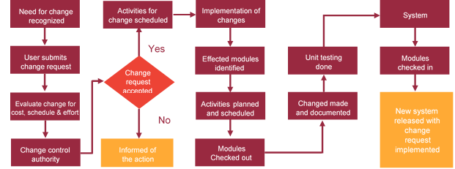

# Miscellaneous

## Acceptance Criteria

* UAT sign off should happen within 14 Days from the release of the application/ Phase and the acceptance confirmation needs to be mailed to Verbat failing which Verbat will consider the project as approved by the client.
* Any comments or reason for rejection need to be documented and the same needs to be sent as an email from the official mail id of client to Verbat.

## General Terms and Conditions

* All the projects activities will be carried out from our off-shore development center in India
* The scope of the project is to develop the Application as detailed in the scope of the project and mentioned in this proposal. Any changes or additions will have to go through change management.
* This proposal and all technical/ functional specifications have been derived or concluded from the data shared via email / information's transferred during the initial requirement analysis meetings and conversations. Verbat reserves the right to amend the terms of this proposal, should the SOW terms, functional features and functionalities change during the course of the project
* Application will be best viewed only in the environment mentioned in this document
* All the documentation will be provided in English.
* Third party components may be used to develop this application.
* All Source Code and other project artefacts would adhere to the Verbat document templates and internal coding standards
* Client shall provide the respective enterprise apple store and Google play store accounts for development and production
* Acceptance criteria shall be based on the clauses which were mutually discussed between Verbat and client at the Requirement Analysis phase and the same will be documented and approved by both parties through official emails
* In case Client requires any extension of the proposed acceptance schedule, the associated effort and cost of such extension can be mutually reviewed.
* For any circumstances if project needs to be put on Hold / Stop it requires minimum request notice period of 2 weeks along with duration for which request will be addressed by management and final decision on the request will be based on that
* If deployment is done in client’s server, Verbat cannot be held responsible for any performance issues arising due to hardware malfunctions.
* Source code will only be delivered or uploaded on the Production Server once the due payments are made.

## Assumptions and Dependencies

* Detailed system study is required before the start of the project.
* During the requirement gathering phase, authorized personnel from the Client’s side is expected to be available for discussion and finalizing the HLD (High Level Design), before development commences.
* Type of reports and formats, if under the scope of the project, needs to be specified by Client before project sign off.
* Workflows if under the scope of the project, need to be specified/ confirmed by client before project signoff.
* All queries regarding the client requirement and any queries which may hinder the project advancement at any stage should be answered by the client within 24 hours from the time of initiation, failing which the time delay will get added to the actual effort which was estimated.
* Verbat assumes that all sign-offs from Client will be provided within agreed and specified timeframe.
* Client will provide all the necessary contents, both text and image, before starting the project in the format suggested by Verbat (if any).
* The client should provide the relevant information and data well in time for the execution of a related activity. Non- availability of this information or data may lead to an interruption of work which may result in a delay in delivery as well as additional costs to the client.

## Source Code & Intellectual Property Rights

* Upon completion of the Project and 100% completion of the payment, client will have access to the source code except for propriety codes, developer tools and third party application etc.
* The solution offered will be the intellectual property of the client and will be made available to the client on an “unlimited license” basis.
* Modifications by third party/person: No person or organization, other than Verbat or any person authorized by Verbat in writing, has any permission to modify/change the software Solution to be eligible to get continued support from Verbat as per the support terms defined under this document.
* Liabilities/Damages: Verbat accepts no liability or damages of any kind arising out of use or non-use of the software delivered. The responsibility of testing of software lies with Client.

## Maintenance & Support

* Maintenance contracts by default are supported as per the basic SLA terms.
* **AMC with Basic SLA is charged at 20 % of the total project value**. Additional Effort/change management request will be added towards Total Value of the Project to determine the AMC value.
* Maintenance support is limited to providing application support for ensuring the consistency of the look-and-feel, bug fixes and user issues i.e. maintenance and support of the existing features of the application.
* Support does not in any way cover providing technical or other support to the end users. The maintenance agreement does not include functionality changes or feature additions which are handled as change requests which will be charged AED 1200 per man day. AMC does not include server support, maintenance and application deployment.
* AMC charges will cover Off-Site Support and Debugging. Support includes E-mail, Telephone and Chat unless explicitly specified. In the event, the application is hosted with the client; necessary remote desktop connectivity should be provided for carrying out maintenance activity.
* Gap in AMC - In case if the client does not opt an AMC for a year and want to renew it after that period, 50% of the AMC amount for the year for which AMC is not taken will also be payable if the client wishes to renew the AMC contract.
* Note:
  + Please note that the AMC support shall start only after all the necessary sign-offs (AMC Document) to this effect have been given.
  + It is not mandatory that the client should opt for an AMC. The client will still be supported on an ad-hoc basis on an agreed man-day rate.
  + AMC Payment Terms: 100% to be paid as advance.

## Service Level Agreement

|  |  |  |  |  |
| --- | --- | --- | --- | --- |
| **Key** | **Max Response Time** | | **Max Resolution Time** | **Target** |
| Basic | 1  working day | 3 working days | | Request / incident / problem tickets |
| Advanced | 5 Business Hours | 12 Business Hours | | Request / incident / problem tickets |
| Priority | 3 Business Hours | 5 Business Hours | | Request / incident / problem tickets |

Note:-

* We provide Basic SLA as standard with AMC while Advanced and Priority SLAs attract additional charges.
* Time zone applicable as per India time zones (3:30 AM GMT to 12:30 PM GMT- Monday to Friday).

# Our Clients

**UAE University**

Education

Transportation

**Canada Cartage**

Construction

Services

Finance

We look forward to hearing from you soon and hope that you will give us the privilege to work with you in meeting your business goals. Thank you.

Thank You



©   
1999 - 2017. All Rights Reserved   
Verbanet Technologies LLC  
www.verbat.com